**HOME RENTAL APP USING MERN STACK**

AJAY RAJ AGARWAL S (2021115009)

DINESH K (202111503)

VISHAL RAJ VELLAISAMY (2021115120)

DILLEEP T (2021115322)

INTRODUCTION:  
  
The **Home Rental App** is a web application built using the MERN stack (MongoDB, Express, React, and Node.js). It provides a platform for users to rent properties while enabling property owners to manage listings and bookings efficiently. The app offers features like user authentication, property management, a booking system, and an admin panel for overseeing users and properties. With secure authentication using JWT and easy image uploads for properties, the app ensures a smooth and seamless experience for both tenants and property owners. Built with React and Node.js, the app provides a dynamic and responsive interface for all users.  
  
The app integrates several key features:

* **User Authentication and Authorization**: Users can register, log in, and manage their profiles securely using JWT (JSON Web Tokens) for authentication.
* **Property Management**: Property owners can post, update, delete, and manage the status of their properties, with an easy-to-use interface for uploading images and details.
* **Booking System**: Tenants can book properties, and owners can handle booking statuses, ensuring smooth interactions between both parties.
* **Admin Panel**: Admin users have the ability to manage users, properties, and bookings, providing oversight and administrative control over the app.
* **File Uploads**: The app supports property image uploads via **Multer**, ensuring the management of media files alongside property details.

**SIGN UP PAGE:  
  
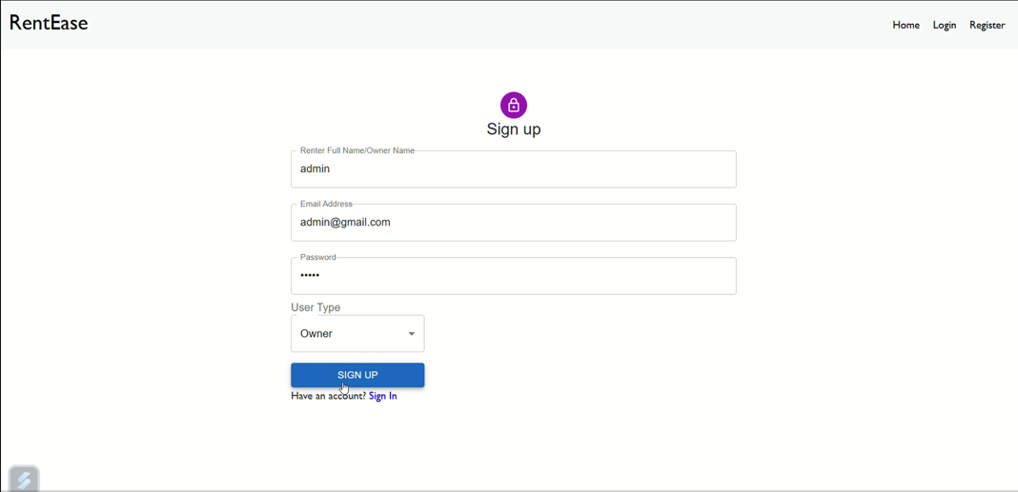**

The Sign-Up Page in the Home Rental App serves as the entry point for users to create their accounts and access the platform's features. It allows individuals to register as either renters, property owners, or administrators by providing essential details such as their name, email address, password, and user type. The user-friendly interface ensures a smooth registration process, with secure password handling and proper role-based categorization. Renters can explore properties, owners can list and manage their rentals, and administrators can oversee the system efficiently. This page also includes a seamless navigation option for users who already have an account, redirecting them to the login page. The design prioritizes simplicity and accessibility, ensuring it caters to diverse users across devices.

**ALL USERS PAGE**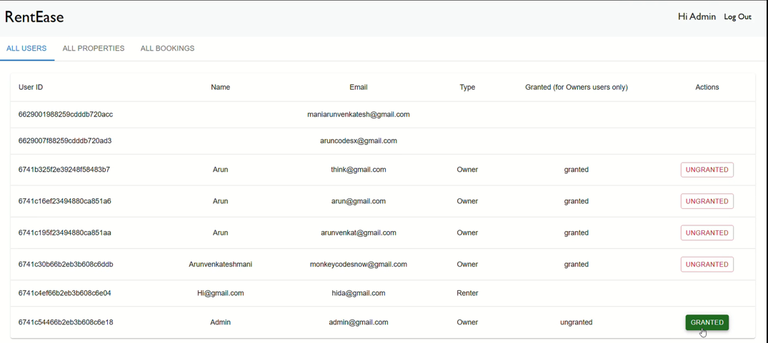The **All Users Page** in the Home Rental App provides administrators with a comprehensive view of all registered users on the platform. This interface displays essential details, including User ID, Name, Email, User Type (Renter or Owner), and their status (Granted or Ungranted). The page is designed to facilitate efficient management of users by offering actionable controls such as granting or revoking access for property owners. This feature ensures the platform maintains appropriate user permissions and roles. With a clean and organized layout, administrators can monitor and manage user activities, enhancing the platform's security and functionality  
  
**ADD PROPERTY PAGE:  
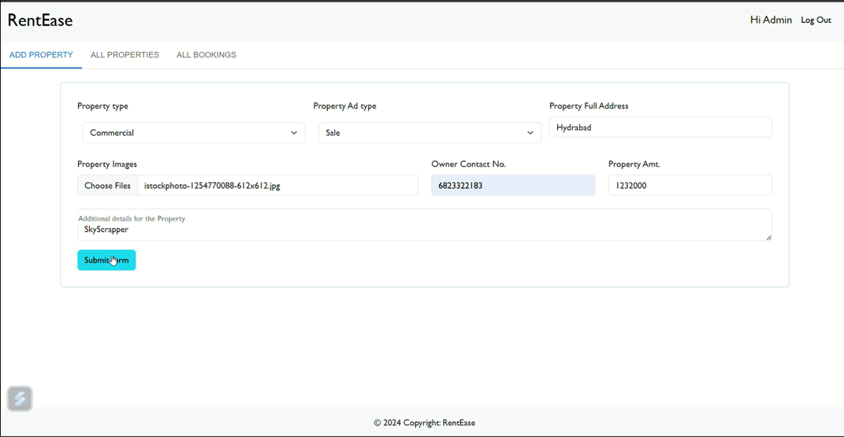**

The Add Property Page in the Home Rental App allows property owners to seamlessly list their properties on the platform. This page provides a user-friendly form where owners can input essential property details, including the property name, location, rental price, description, and upload images for better visualization. The intuitive design ensures that all necessary information is captured to create an appealing listing for renters. By streamlining the property addition process, this feature empowers owners to efficiently manage their properties while enhancing the platform's inventory for potential renters.

**MODAL HEADING:  
  
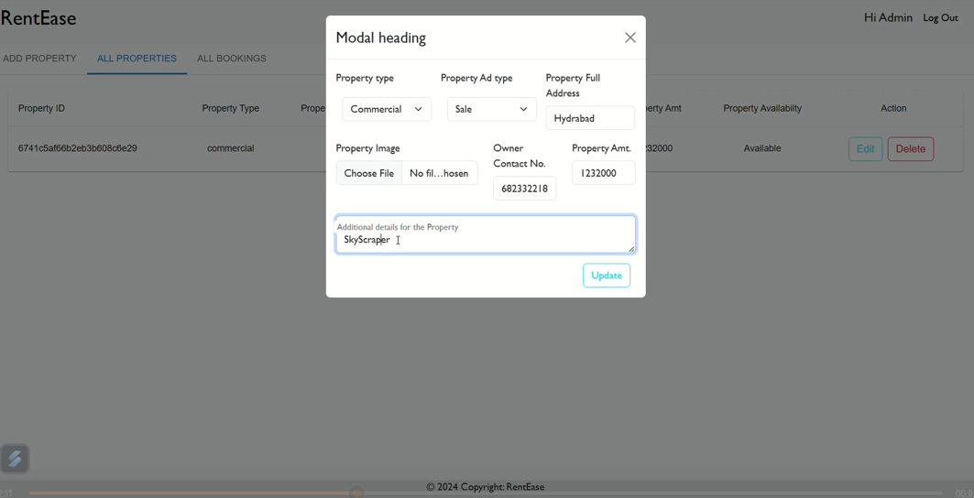**The Modal Heading in the Home Rental App provides an intuitive and user-friendly interface for editing property details. When users click "Edit" in the "All Properties" section, a pop-up modal is displayed, streamlining the process of updating essential property information. This modal includes fields for modifying the property type (e.g., apartment, villa, etc.), advertisement type (e.g., sale or rent), full property address, and the property's primary image. Additionally, it allows users to update the owner's contact information and specify the rental or sale amount for the property.

The modal's design eliminates the need for users to navigate to a separate page, enhancing usability and efficiency. With a clear and organized layout, it ensures that all necessary property attributes can be updated in one place. After making the changes, users can click the "Update" button to save the revised details instantly. This feature ensures that property listings remain accurate and up-to-date, benefiting both property owners and potential renters or buyers.

**ALL PROPERTIES PAGE :  
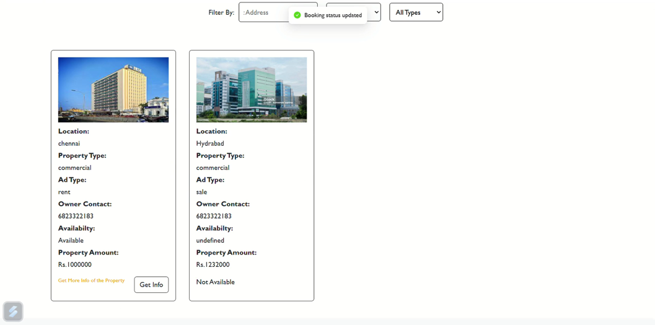**The All Properties Page in the Home Rental App serves as a centralized hub for managing and viewing all listed properties. This page is designed to provide a comprehensive overview of properties, catering to both property owners and renters. Key details such as property ID, name, type, address, contact information, and rental or sale price are displayed in an organized tabular format, enabling users to access critical information at a glance.

For property owners, the page includes actionable features such as "Edit" and "Delete" options for each listing, ensuring seamless management of their properties. The "Edit" option triggers a modal where owners can update details like property type, advertisement type, address, image, contact information, and price. This interactive functionality enhances the user experience by allowing real-time modifications without navigating away from the page.

**CONFIRM BOOKING  
  
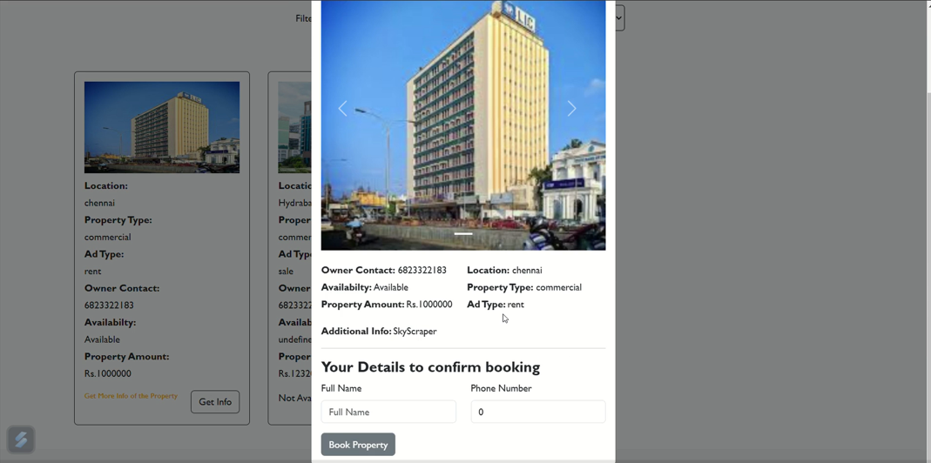**

This section in our Home Rental Application allows users to seamlessly book a property by submitting their details through an intuitive form. This feature enhances user interaction and ensures that all necessary booking information is collected efficiently.

**Key Components**

1. **Form Fields:**
   * **Full Name:** Captures the name of the user making the booking.
   * **Phone Number:** Ensures the owner or admin can contact the user for booking confirmations or further queries.
2. **Integration with Backend:**
   * The form data is securely sent to the backend via API endpoints, ensuring confidentiality and reliability.
   * The booking details, including the user input, are stored in the database for further processing and management.
3. **Validation:**
   * The application includes validation for mandatory fields to ensure complete and accurate data entry.
   * Phone numbers are verified to confirm they are in a valid format before submission.
4. **Button Functionality:**
   * **"Book Property" Button:** Submits the form data to the server and triggers the backend process for booking the selected property.

**Implementation Details**

* **Frontend Technology:**
  + The form is built using React.js with controlled components for managing input states.
  + The UI is styled to provide a clean and responsive design, ensuring ease of use across devices.
* **Backend Integration:**
  + The bookingHandleController in the backend handles the submission of booking details. It verifies the property ID and associates the booking request with the corresponding property.
  + JWT-based authentication ensures only authorized users can make bookings.
* **Data Flow:**
  + User fills in the form fields.
  + The "Book Property" button triggers an API call with the user's details.
  + The backend processes the booking and updates the property’s status.

**FORGET PASSWORD**

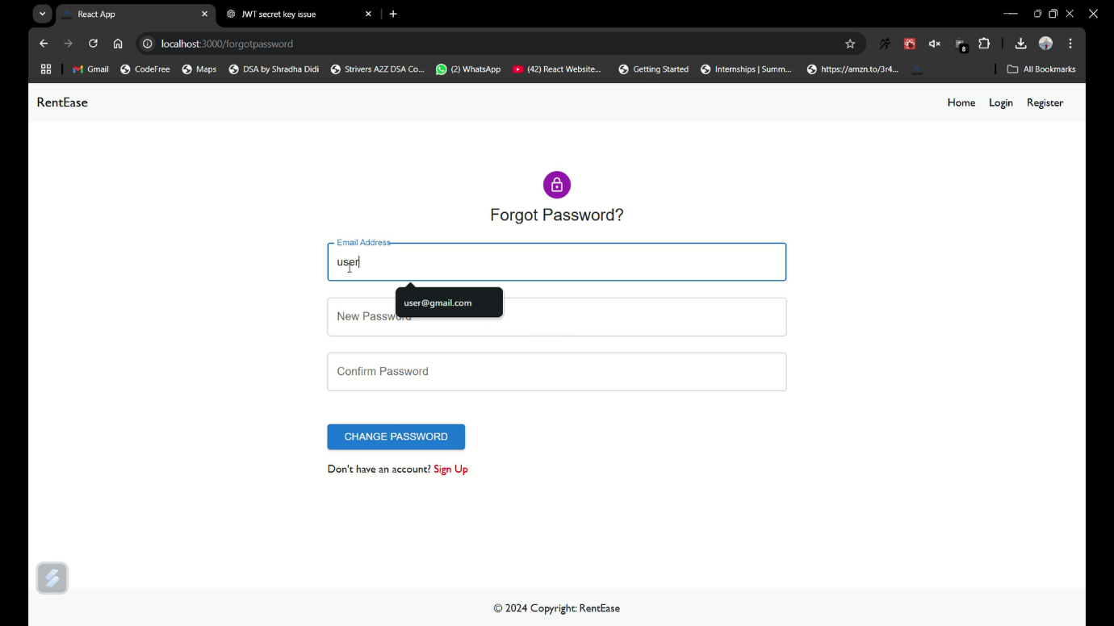

The Forgot Password functionality in the Home Rental App enables users to reset their password in case they forget it. This feature ensures that users can regain access to their accounts without needing to create a new account. It is a critical aspect of user authentication and security, ensuring a seamless user experience.

Implementation

The forgot password functionality is implemented using the following steps:

1. User Input: The user provides their registered email address.
2. Backend Processing: The backend checks whether the email exists in the database. If it exists, it proceeds to hash the new password provided by the user and update the user's record in the database.
3. Security: The new password is hashed using bcryptjs to ensure secure storage and prevent plain-text password storage in the database.
4. Confirmation: Once the password is updated successfully, the backend sends a confirmation message to the user.

**USER AUTHENTICATION**User authentication is an essential feature in the Home Rental App, allowing users to securely log in, register, and manage their profiles. The authentication system uses JWT (JSON Web Tokens) for managing user sessions, ensuring secure access to the app's features.

Implementation

The authentication system includes:

* Registration: New users can register by providing details like email, password, and user type (Tenant or Owner).
* Login: Users log in with their email and password. If credentials are valid, a JWT token is generated and returned.
* Password Hashing: Passwords are hashed using bcryptjs before storing them in the database for enhanced security.
* JWT Token: The generated JWT token is used to authenticate requests, ensuring only authorized users can access certain routes.

**Property Management**

The property management section is crucial for property owners to list, update, or delete properties they are offering for rent. It also allows owners to view bookings for their listed properties.

**Implementation**

* **Add Property**: Owners can add new properties by submitting details such as property type, price, and location. They can also upload images using multer.
* **Update Property**: Owners can update property details, including images and descriptions.
* **Delete Property**: Owners can delete properties they no longer wish to rent.
* **View All Properties**: Owners can view all properties they have listed.

**Booking Management**

Booking management allows tenants to book properties, and owners to manage the status of bookings. This feature is key for ensuring the smooth operation of the rental system.

**Implementation**

* **Booking Creation**: Tenants can book properties by sending a booking request to the backend.
* **Booking Status**: Owners can update the status of bookings, such as confirming or rejecting a booking.
* **View Bookings**: Both tenants and owners can view all bookings associated with their accounts.

**Admin Panel**

The admin panel provides an interface for administrators to manage the entire system. Admins can view all users, properties, and bookings, as well as change user roles or property status.

**Implementation**

* **Manage Users**: Admins can view all registered users, including both tenants and owners.
* **Manage Properties**: Admins can view and modify the details of all listed properties.
* **Manage Bookings**: Admins can view all bookings and update statuses as needed.

**Conclusion**

The **Home Rental App** developed using the MERN stack provides a comprehensive solution for property rental management. The app includes essential features such as user authentication, property management, booking handling, and a robust admin panel.

By implementing JWT-based user authentication and securely handling password resets, the app ensures a secure and reliable user experience. Property owners can easily list, update, and delete properties, while tenants can browse available properties and make bookings. The admin panel streamlines the management of users, properties, and bookings, offering full control over the system.

With these features, the **Home Rental App** offers an efficient and scalable solution for property rentals, leveraging the power of the MERN stack to provide a modern and seamless experience for users, property owners, and administrators.